Assignment 3 STiC
Name: Ahmed Ali Raja
Reg No : 7864

MobileNetV2
MobileNetV2 is a type of computer program, or a neural network, designed by Google to be very efficient11. Think of it as a highly trained photo-detector that is specifically designed to run fast on small devices like mobile phones or other places where the computer does not have a lot of power22.
Importance
MobileNetV2 achieves its speed and efficiency by using a clever technique called inverted residuals and linear bottlenecks. In simple terms, this means it processes the information from the picture in a very smart and condensed way, saving on memory and calculation time without losing too much accuracy.

Use in Code
The part of the code that builds the model is:
Python
def build_model :
base = MobileNetV2 include_top=False, input_shape= 32, 32, 3 , weights=None
X = GlobalAveragePooling2D base.output
output = Dense num_classes, activation= softmax X
model = Model inputs=base.input, outputs=output
return model
The Base Model: The code loads the MobileNetV2 structure55.
include_top=False: This means we are using the main MobileNetV2 engine, but we are removing the very last guessing layers that it normally uses66.
input_shape= 32, 32, 3 : This tells the model the pictures it will look at are $32$ pixels by $32$ pixels, with $3$ color channels Red, Green, Blue 77.
weights=None: This tells the program to start learning from scratch, instead of using knowledge it might have gained from other pictures88.
GlobalAveragePooling2D: This is a layer that simplifies the complex information from the MobileNetV2 engine into a simpler set of features.
Dense num_classes, activation= softmax : This is the new final guessing layer. It has 10 possible answers num_classes = 10 and uses softmax to pick the most likely answer e.g., It's 90% a cat and 10% a dog 99.

Results with MobileNetV2
The results show how well the chosen MobileNetV2 structure performed when taught using the five different Adam optimizer rules1010.
The Best Val Accuracy Validation Accuracy is the most important score because it shows how well the MobileNetV2 model can generalize, or guess, the correct category for a picture it hasn't seen before1111.
The highest score achieved was $\mathbf{0.6208}$ with the low beta2 setting1212.This means that even with the efficient MobileNetV2 structure, the model was only able to correctly identify the validation pictures about $62\%$ of the time1313.
In conclusion, MobileNetV2 was successfully used as the core structure for image classification, but the relatively low final accuracy suggests the model either needs more training time or perhaps a larger input image size to capture enough detail for better performance on the CIFAR-10 images16161616

CODE
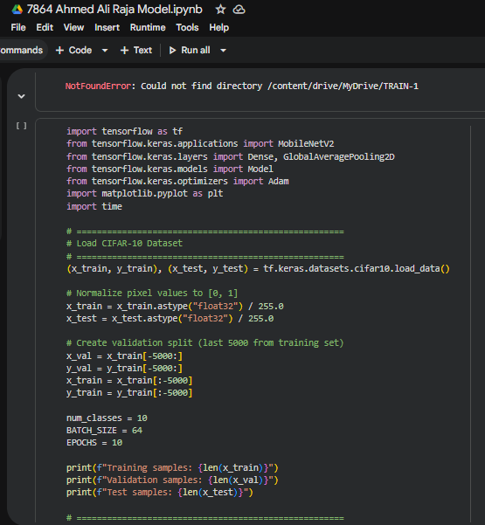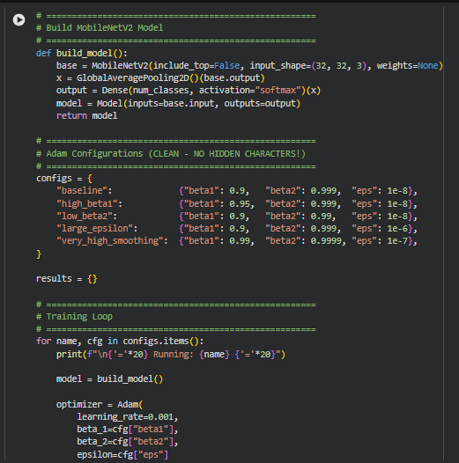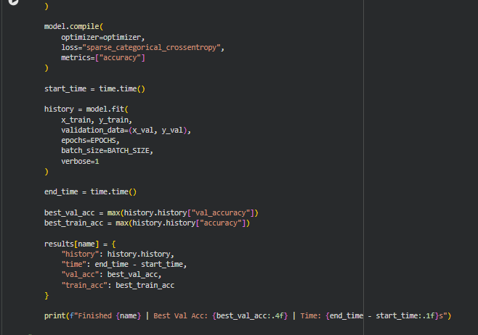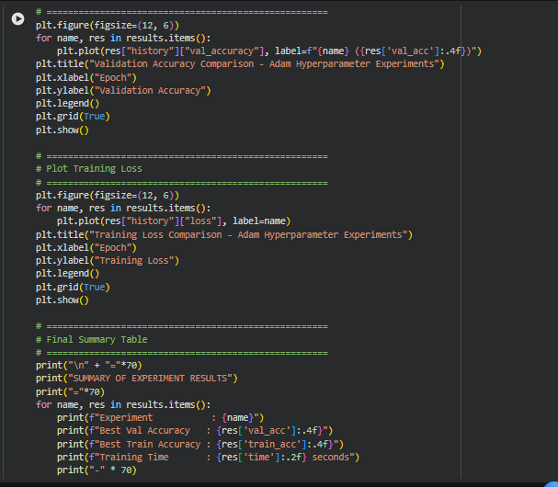

OUTPUT

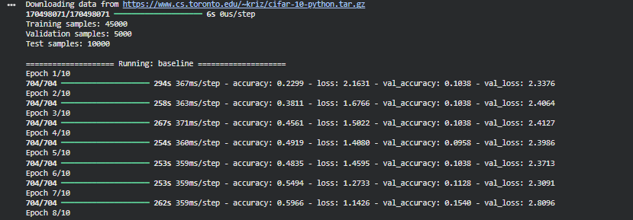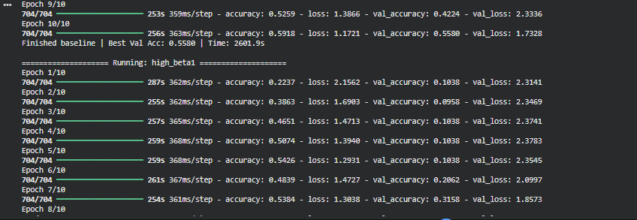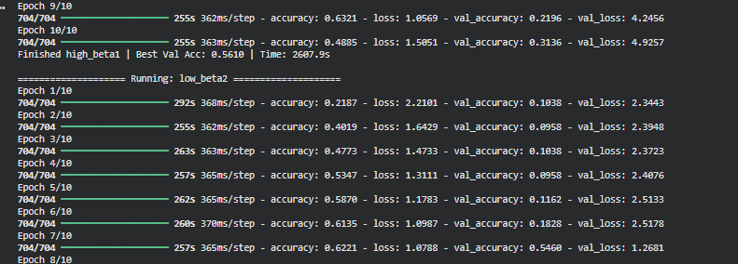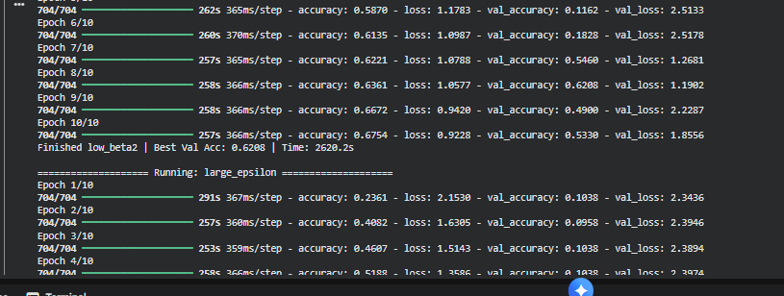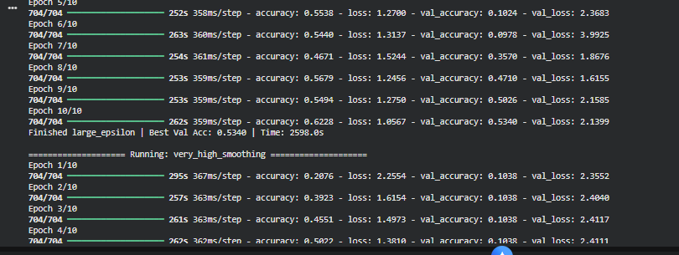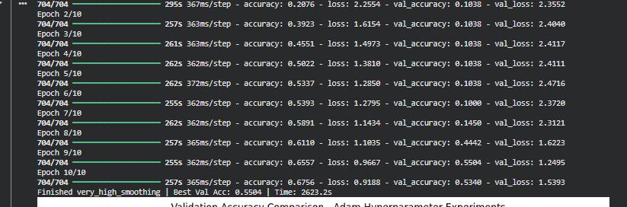

Graphs

